ZykaExpress- Online Food Delivery System

# Project Member:

Vaibhav Singh (240341220209)

Akash Kendre (240341220087)

Bharat F. ()

# ABSTRACT

ZykaExpess offers a seamless web application designed to revolutionize the homemade food market by facilitating easy access for customers to purchase locally prepared meals. This platform stands out by enabling users to register, explore diverse menu types, select from a variety of menus, manage orders, and enjoy comprehensive order-to-delivery-to-payment services. Mirroring the operational model of established food delivery services like Zomato and Swiggy, ZykaExpress connects customers with a curated selection of home kitchens, streamlining the food ordering process from selection to delivery. Once an order is placed, the system efficiently processes the details and assigns a delivery partner available in the customer's region, ensuring timely and reliable service. The technical backbone of ZykaExpress is built on React front-end for a user interface experience, and a MySQL database integrated with Spring Boot (J2EE) for the back-end to manage the application's data and operations securely.

# 1. INTRODUCTION TO PROJECT

ZykaExpress introduces an innovative web application designed to redefine the homemade food delivery experience. This system embraces the core concepts of food shopping online and focuses on local, homemade culinary delights. Within ZykaExpress, customers can effortlessly navigate through an extensive menu categorized by food types. Our platform is particularly user-friendly, offering a streamlined process for adding selected homemade dishes to the cart based on their preferences and descriptions. Order placement is intuitive, requiring customers to specify a delivery address from their pre-saved list—though only one address can be chosen per order. The system mandates the provision of a delivery address to proceed with the order. Following address selection, customers choose their payment method, completing the order process with ease. These actions trigger real-time updates in the database, ensuring accuracy and reliability. ZykaExpress administrative features are robust, allowing for the addition or removal of menu types and items by the platform's admin. Admin can monitor the order-to-delivery process for every customer.

# 2. PROJECT OVERVIEW AND SUMMARY

## PURPOSE

The purpose of the ZykaExpress project is to enhance the experience of purchasing homemade food. It's very difficult to get homemade food when you are staying in the other city far from your hometown. ZykaExpress is proposed as a solution to these challenges, offering an online platform that facilitates easy access to a wide variety of homemade foods. This project is designed to make the process of ordering homemade meals convenient and accessible to everyone, directly from the comfort of their homes. By leveraging a web-based application, ZykaExpress enables users to explore and order from an extensive selection of homemade dishes, streamlining the entire process from order to delivery.Key features of ZykaExpress include the ability to keep track of purchase orders, view detailed menus and dishes available from home kitchens, and manage order details and delivery options. The system is designed to maintain a history of orders and their respective timings, enhancing the customer experience through efficient service and delivery. The admin panel of ZykaExpress events related to kitchens, users, and delivery from order receipts to delivery status. Through ZykaExpress, we aim to revolutionize the way people access homemade meals, providing a user-friendly, efficient, and secure platform that bridges the gap between home chefs and customers seeking authentic, homemade culinary experiences.

## SCOPE

* Currently, purchasing homemade food has become a challenge in urban areas due to logistical constraints like traffic and distance.
* Small and medium-scale home kitchens face difficulties in managing customer data and the services offered to them, particularly because many rely on inefficient paper-based systems.
* It is challenging for these home-based food providers to maintain comprehensive data over extended periods due to the limitations of their current record-keeping methods.
* Customers often find it challenging to locate nearby food providers that offer authentic and homemade meals, reflecting a gap in the market for a service that connects them directly with home chefs.
* ZykaExpress addresses these challenges by providing a digital platform where home kitchens can efficiently manage data related to customers and the services they offer, moving away from unreliable paper-based systems to a secure, scalable online solution.
* From the customer's perspective, ZykaExpress simplifies the decision-making process by offering a diverse selection of homemade meals across various categories, sourced from multiple home kitchens. This ensures ease of choice and access to authentic homemade food.

# 3. USER CLASSES AND CHARACTERISTICS

In the ZykaExpress platform, an Administrator plays a pivotal role, with the capability to introduce new categories of homemade menu items, enriching the variety and options available to customers. This feature allows the platform to cater to a wide range of culinary preferences and dietary requirements, ensuring a diverse and inclusive selection of homemade meals.

Customers are encouraged to register on the ZykaExpress platform, a process designed to be straightforward and user-friendly. Once registered, they gain access to a vast selection of homemade dishes, enabling them to explore, choose, and order their favorite meals from the comfort of their homes. The platform facilitates an easy browsing experience, allowing customers to discover new and traditional homemade dishes across various categories.

Home Kitchens, rather than restaurants, are invited to register and list their homemade food products. This feature is designed to provide home chefs with a digital storefront through which they can reach a wider audience, showcase their culinary skills, and manage orders efficiently. It offers a unique opportunity for small-scale food providers to participate in the digital economy and connect with customers seeking authentic homemade meals.

Delivery Personnel are integrated into the system with features that enable them to view the list of orders and their current statuses. This functionality ensures that delivery personnel are well-informed of their delivery schedules, contributing to a seamless and efficient order-to-delivery process. It supports real-time updates and tracking, enhancing the delivery experience for both the customers and the delivery team.

# 4. TECHNOLOGIES USED

* MySQL
* React-JS
* Spring Boot

# 5. FUNCTIONAL REQUIREMENTS

The major functionality of this project is divided into four categories.

* Administrative Functions.
* Customer Functions.
* Kitchen Functions.
* Delivery Boy Functions.

In this application every user must have their Email ID and Password, using these Email IDs and Password only they can directly enter into their corresponding Login forms.

System analysis will be performed to determine if it is feasible to design information based on the policies and plans of the organization and user requirements and to eliminate the weaknesses of the present system.

**6. ER-DIAGRAM**

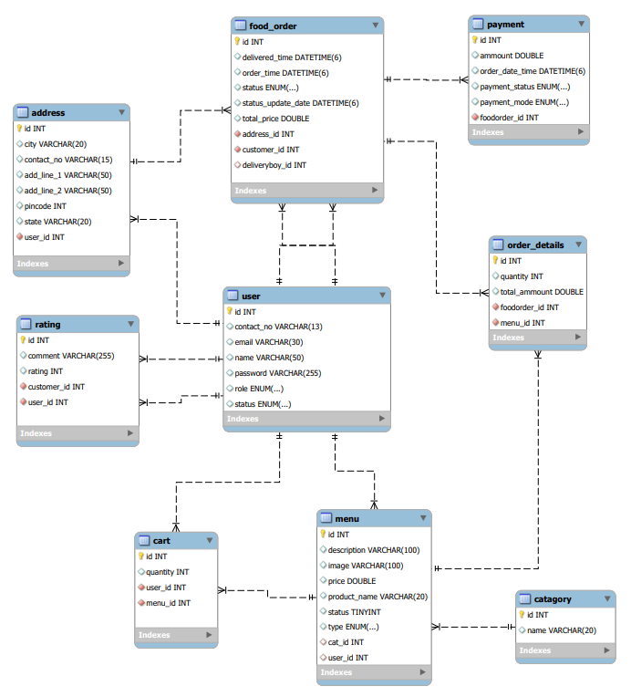

# 7. USE-CASE

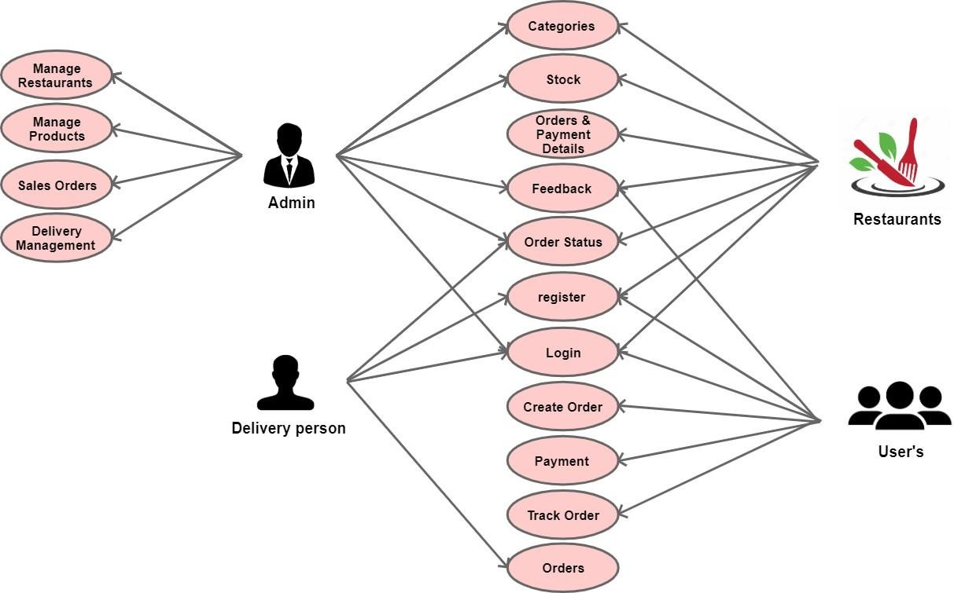

# 8. DATABASE DESIGN

**Users**

|  |  |  |  |  |  |
| --- | --- | --- | --- | --- | --- |
| **Field** | **Type** | **Null** | **Key** | **Default** | **Extra** |
| id | int | No | PRI | NULL | auto_increment |
| email | varchar | No | UNI | NULL |  |
| name | varchar | Yes |  | NULL |  |
| password | varchar | No |  | NULL |  |
| contact | varchar | Yes |  | NULL |  |
| status | enum | NO |  | NULL |  |
| role | varchar | Yes |  | NULL |  |

**Addresses**

|  |  |  |  |  |  |
| --- | --- | --- | --- | --- | --- |
| **Field** | **Type** | **Null** | **Key** | **Default** | **Extra** |
| id | int | No | PRI | NULL | auto_increment |
| address_line_1 | Varchar | Yes |  | NULL |  |
| address_line_2 | Varchar | Yes |  | NULL |  |
| city | Varchar | Yes |  | NULL |  |
| contact | Varchar | No |  | NULL |  |
| pin_code | Varchar | Yes |  | NULL |  |
| state | varchar | Yes |  | NULL |  |
| user_id | int | No | MUL | NULL |  |

**Cart**

|  |  |  |  |  |  |
| --- | --- | --- | --- | --- | --- |
| **Field** | **Type** | **NULL** | **Key** | **Default** | **Extra** |
| id | int | NO | PRI | NULL | auto_increment |
| quantity | int | NO |  | NULL |  |
| user_id | int | YES | MUL | NULL |  |
| menu_id | int | YES | MUL | NULL |  |

**Category**

|  |  |  |  |  |  |
| --- | --- | --- | --- | --- | --- |
| **Field** | **Type** | **NULL** | **Key** | **Default** | **Extra** |
| id | int | NO | PRI | NULL | auto_increment |
| name | varchar | YES |  | NULL |  |

**Menu**

|  |  |  |  |  |  |
| --- | --- | --- | --- | --- | --- |
| **Field** | **Type** | **Null** | **Key** | **Default** | **Extra** |
| id | int | No | PRI | NULL | auto_increment |
| description | varchar | Yes | UNI | NULL |  |
| product_name | varchar | Yes |  | NULL |  |
| image | varchar | Tes |  | NULL |  |
| price | double | Yes |  | NULL |  |
| Status | tinyInt | yes |  | NULL |  |
| category_id | int | Yes | MUL | NULL |  |
| type | enum('VEG','NONVEG') | YES |  | NULL |  |
| rest_id | int | No | MUL | NULL |  |

**Payments**

|  |  |  |  |  |  |
| --- | --- | --- | --- | --- | --- |
| **Field** | **Type** | **Null** | **Key** | **Default** | **Extra** |
| id | int | No | PRI | NULL | auto_increment |
| amount | double | No |  | NULL |  |
| order_date_time | datetime | Yes |  | NULL |  |
| payment_status | varchar | Yes |  | NULL |  |
| payment_mode | varchar | Yes |  | NULL |  |
| foodorder_id | int | Yes | MUL | NULL |  |

**food_order**

|  |  |  |  |  |  |
| --- | --- | --- | --- | --- | --- |
| **Field** | **Type** | **Null** | **Key** | **Default** | **Extra** |
| id | int | NO | PRI | NULL | auto_increment |
| delivered_time | datetime(6) | Yes |  | NULL |  |
| order_time | datetime(6) | Yes |  | NULL |  |
| status | enum | Yes |  | NULL |  |
| status_update_date | datetime(6) | NO |  | NULL |  |
| total_price | double | NO |  | NULL |  |
| address_id | int | NO | MUL | NULL |  |
| customer_id | int | NO | MUL | NULL |  |
| deliveryboy_id | int | NO | MUL | NULL |  |

**Rating**

|  |  |  |  |  |  |
| --- | --- | --- | --- | --- | --- |
| **Field** | **Type** | **Null** | **Key** | **Default** | **Extra** |
| id | int | No | PRI | NULL | auto_increment |
| comment | Varchar | Yes |  | NULL |  |
| rating | int | Yes |  | NULL |  |
| customer_id | int | No | MUL | NULL |  |
| user_id | int | No | MUL | NULL |  |

**Order_Details**

|  |  |  |  |  |  |
| --- | --- | --- | --- | --- | --- |
| **Field** | **Type** | **Null** | **Key** | **Default** | **Extra** |
| id | int | No | PRI | NULL | auto_increment |
| total_ammount | double | No |  | NULL |  |
| quantity | int | No |  | NULL |  |
| foodorder_id | int | No | MUL | NULL |  |
| menu_id | int | No | MUL | NULL |  |

**9.Screenshots :**

Home Page

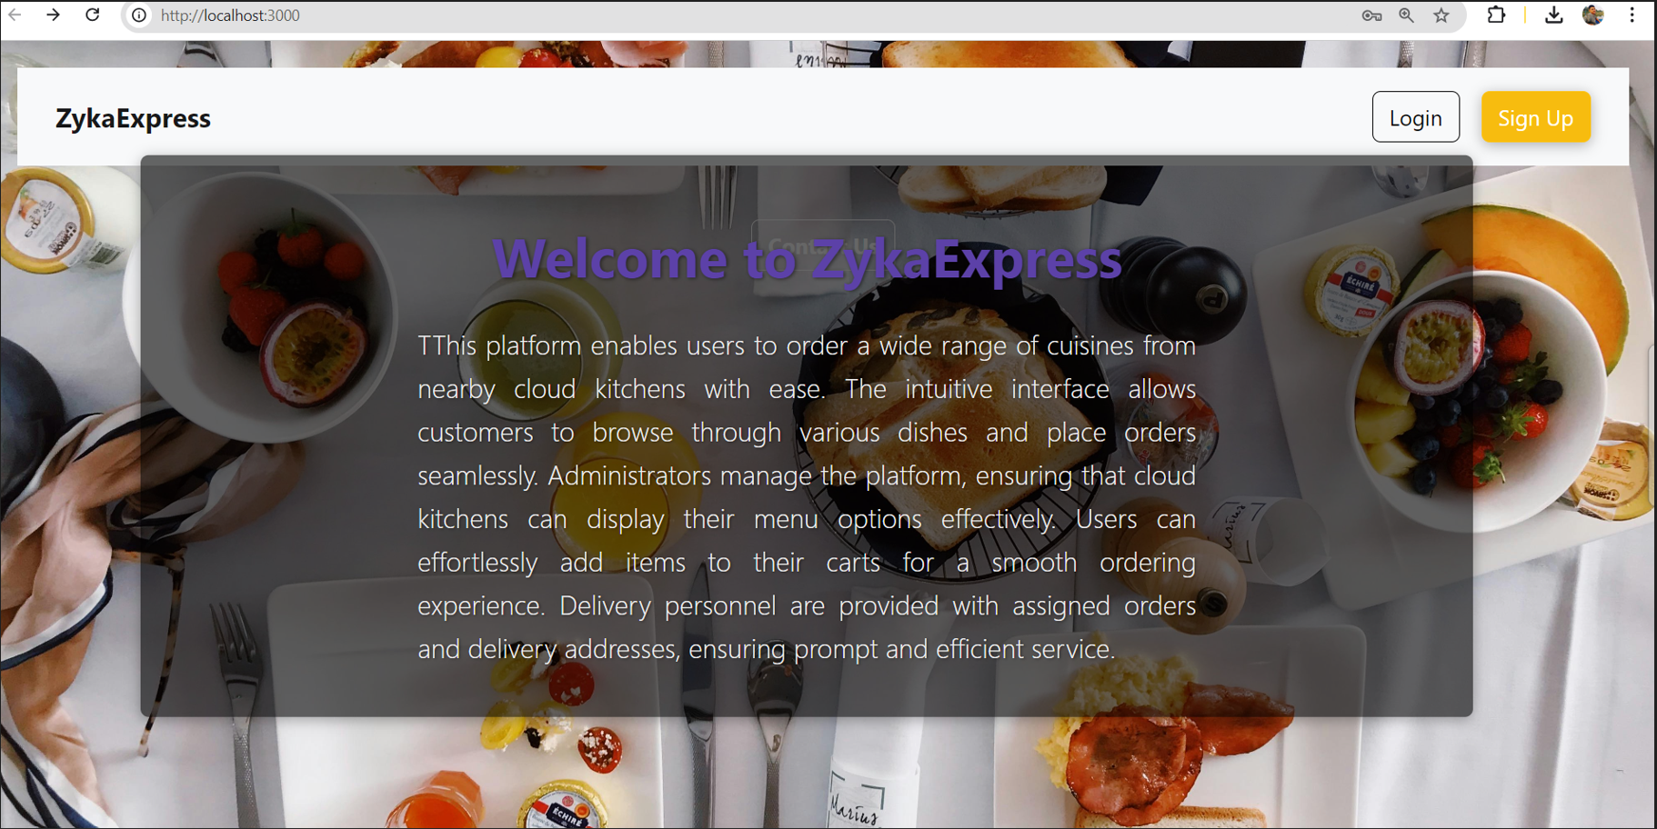

Sign In

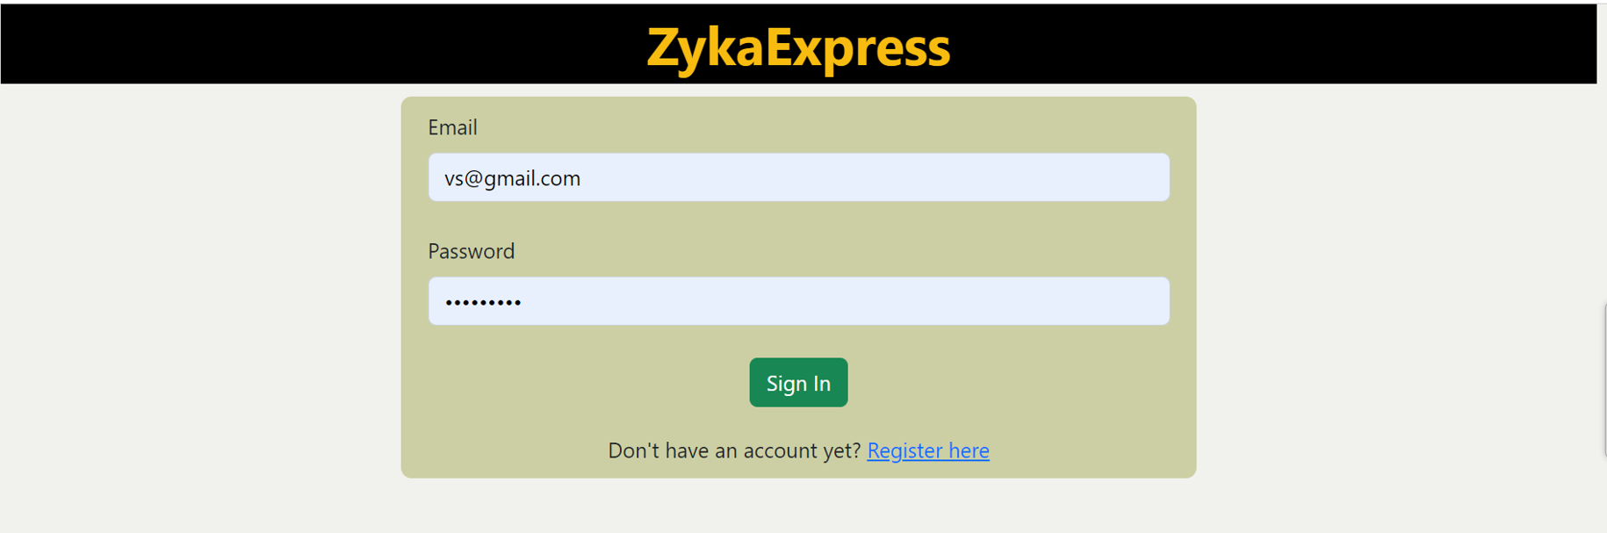

SignUp

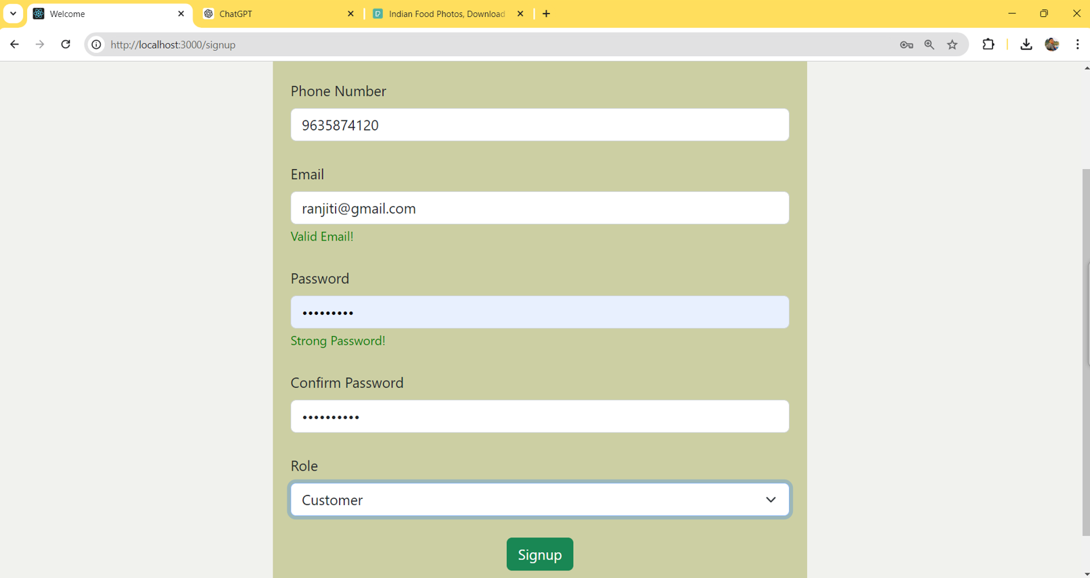

Customer Home

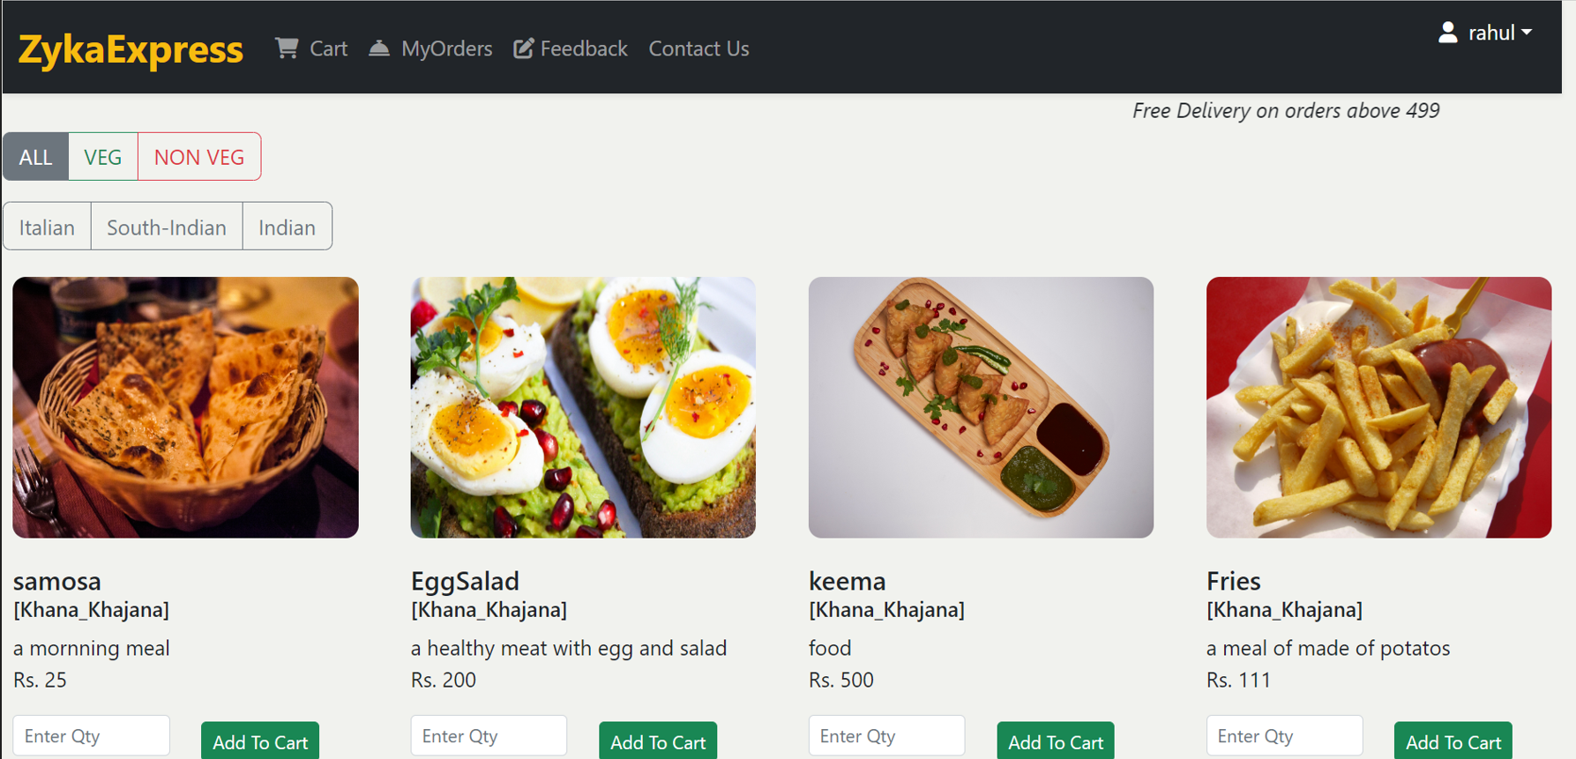

Customer Cart

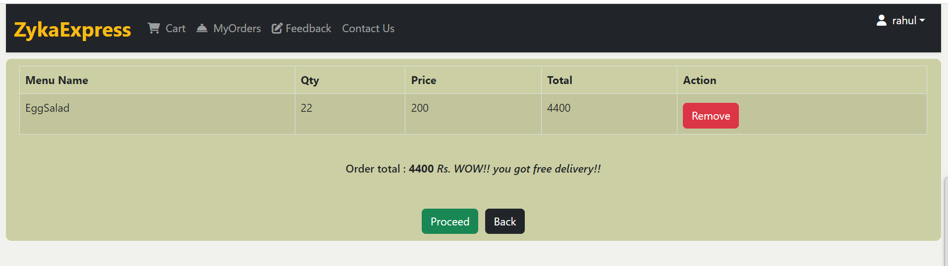

Customer Orders

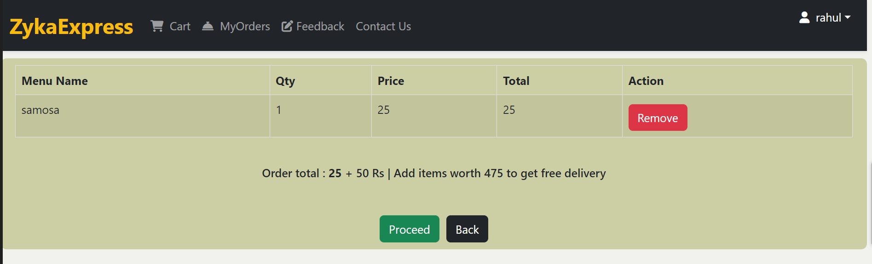

Rating

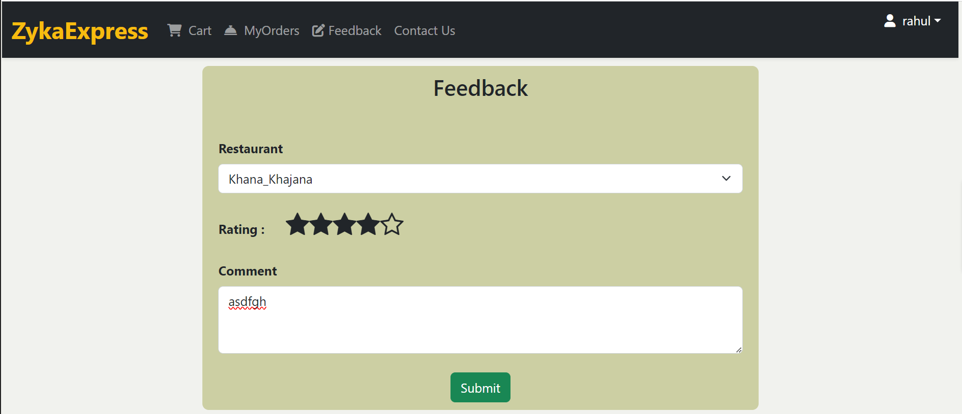

Update Profile

Restaurant Home (New Orders)

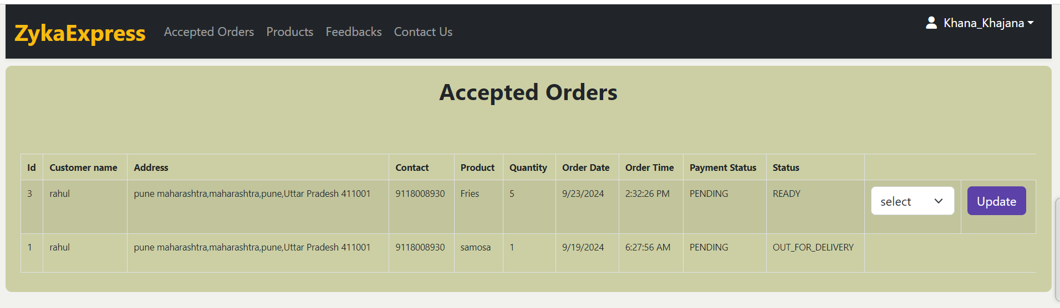

Restaurant Accepted Orders

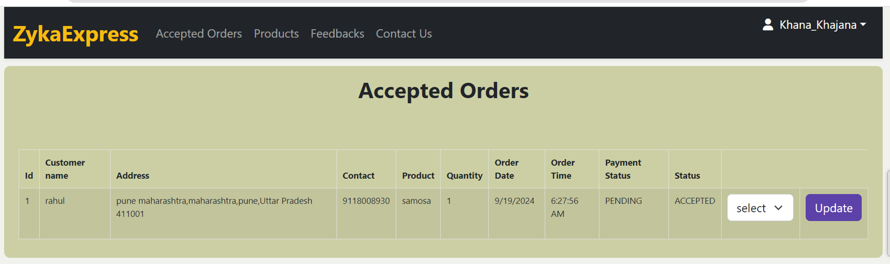

Restaurant Products

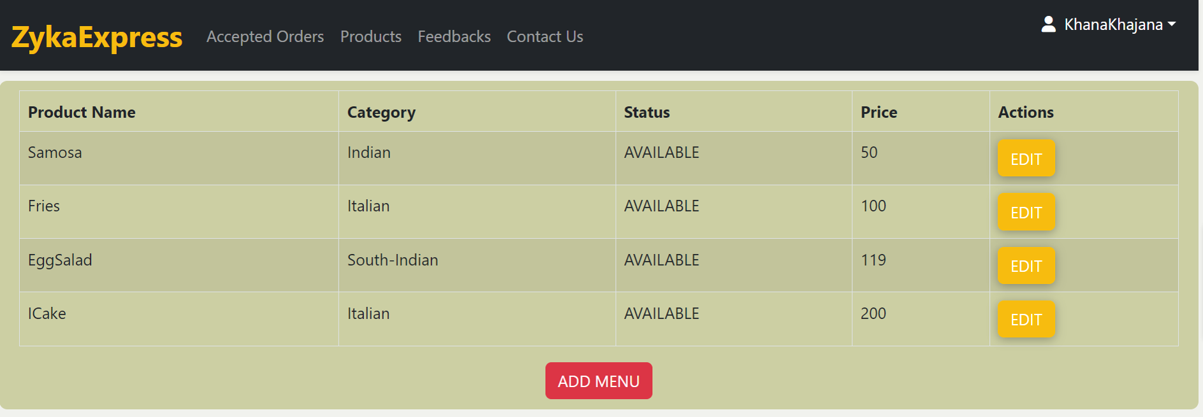

Restaurant Feedbacks

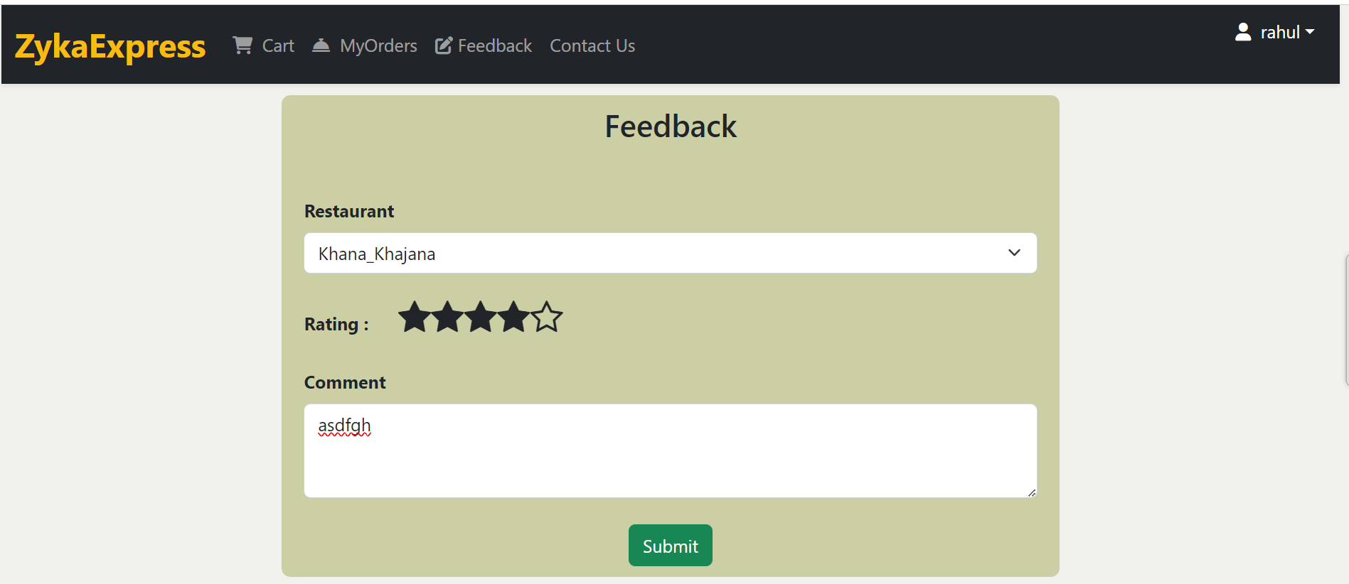

DeliveryBoy Home (New Orders)

DeliveryBoy Accepted Orders

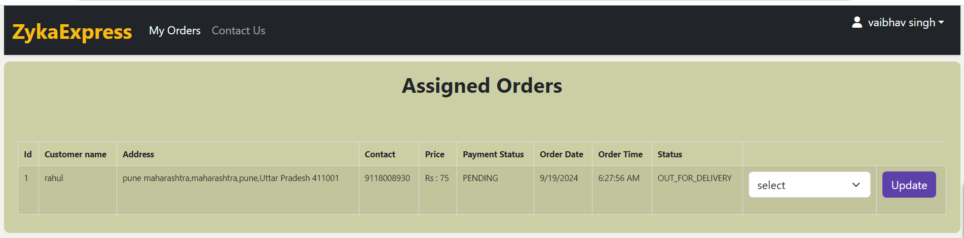

Admin Home

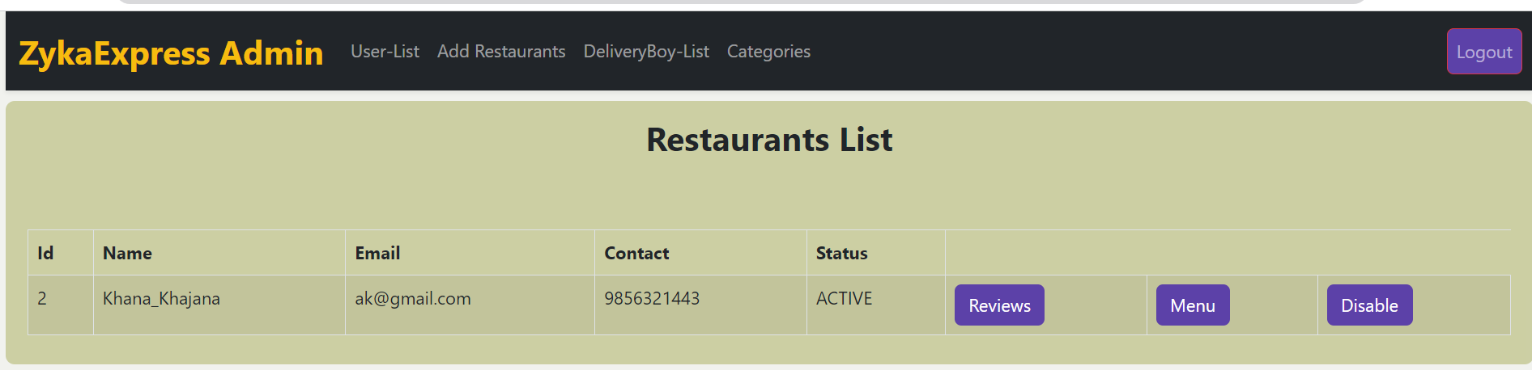

Customers List

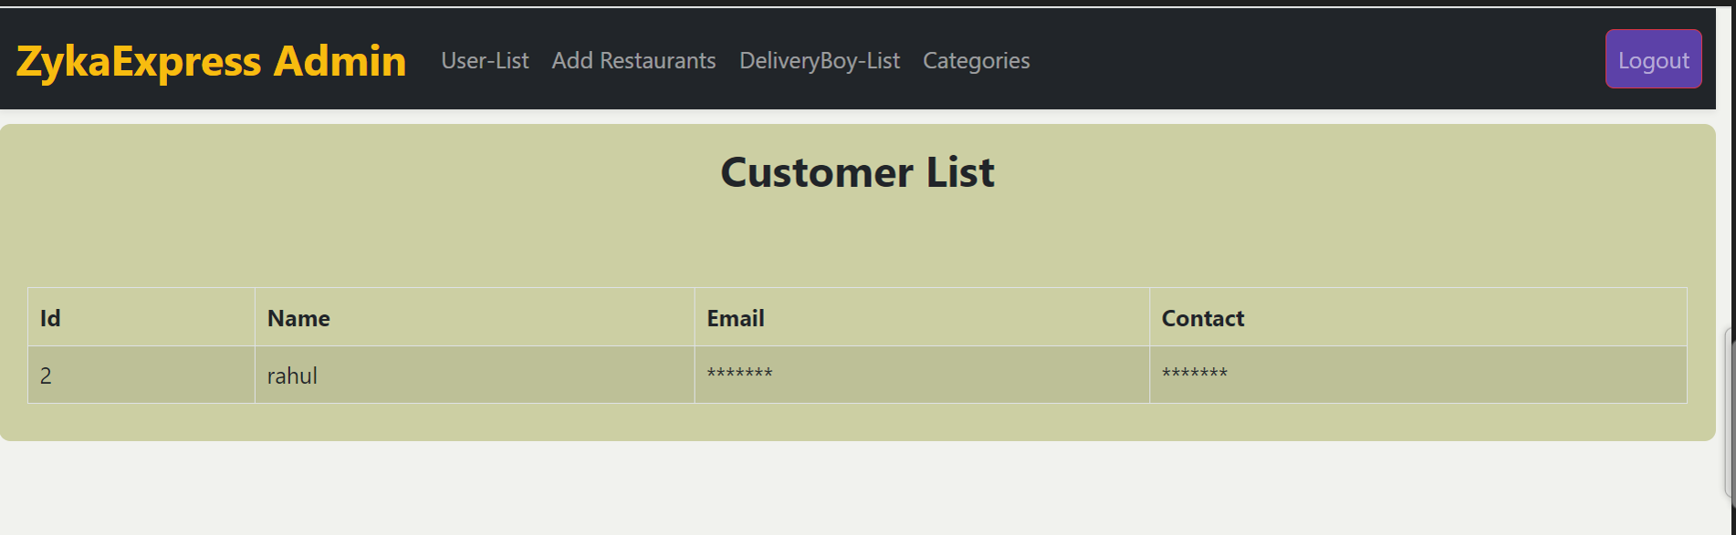

DeliveryBoy List

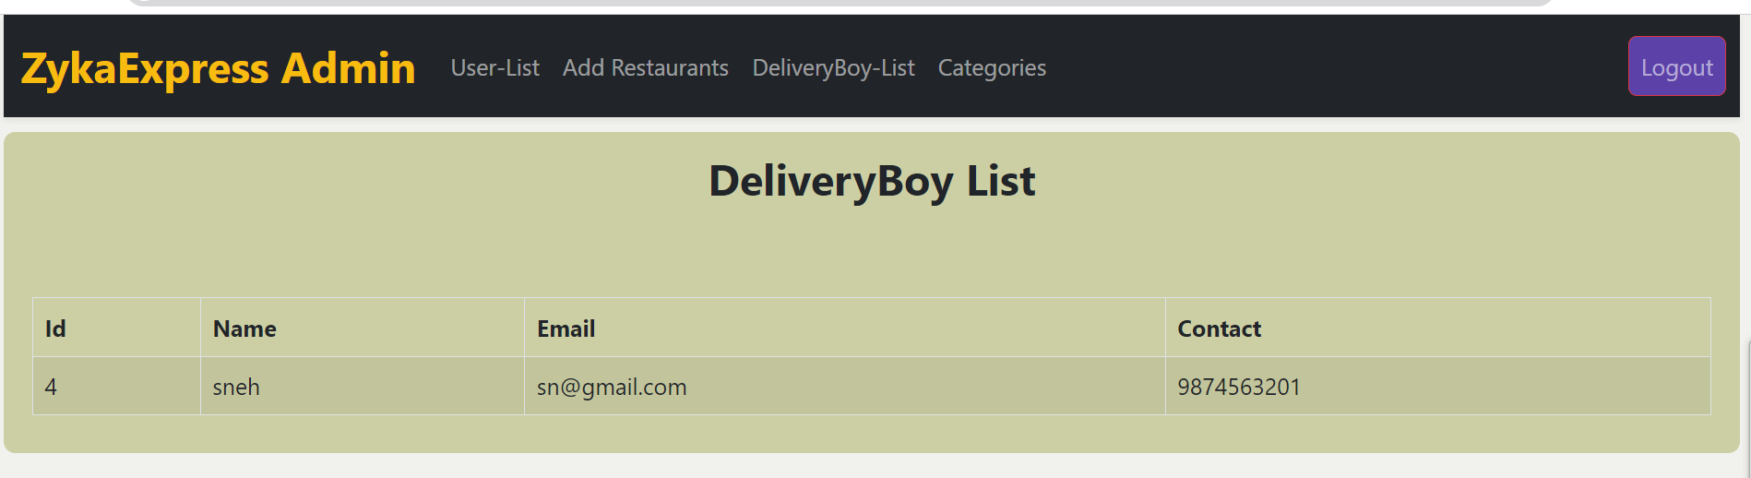

Admin Add Restauent

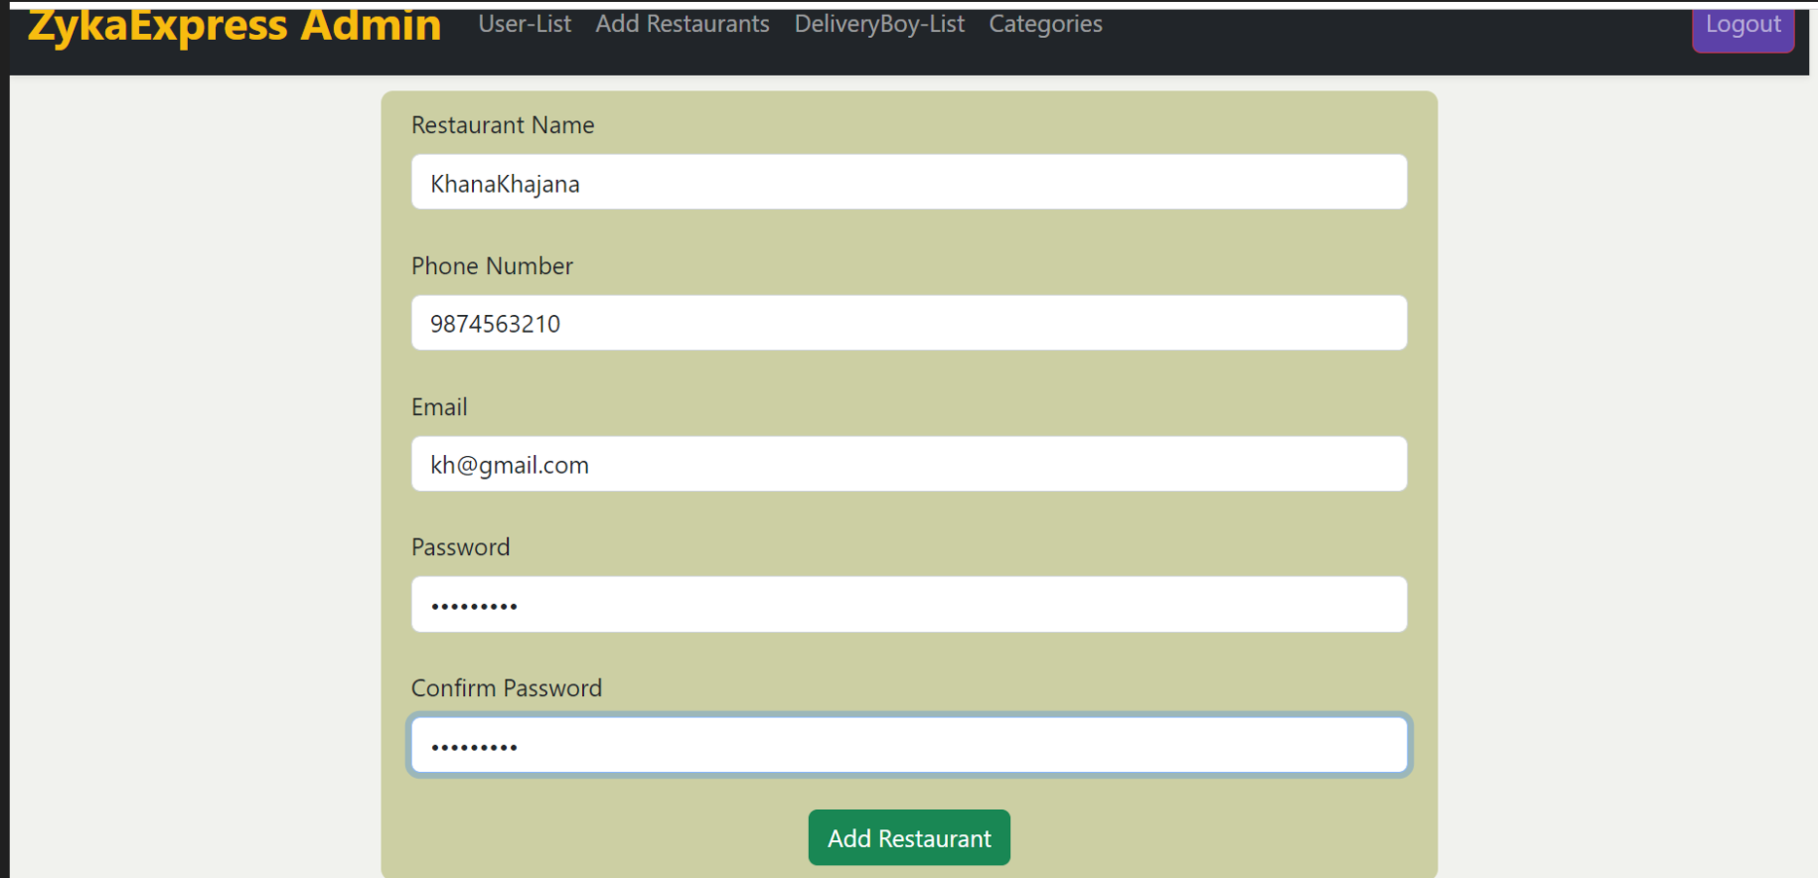

Admin Add Category

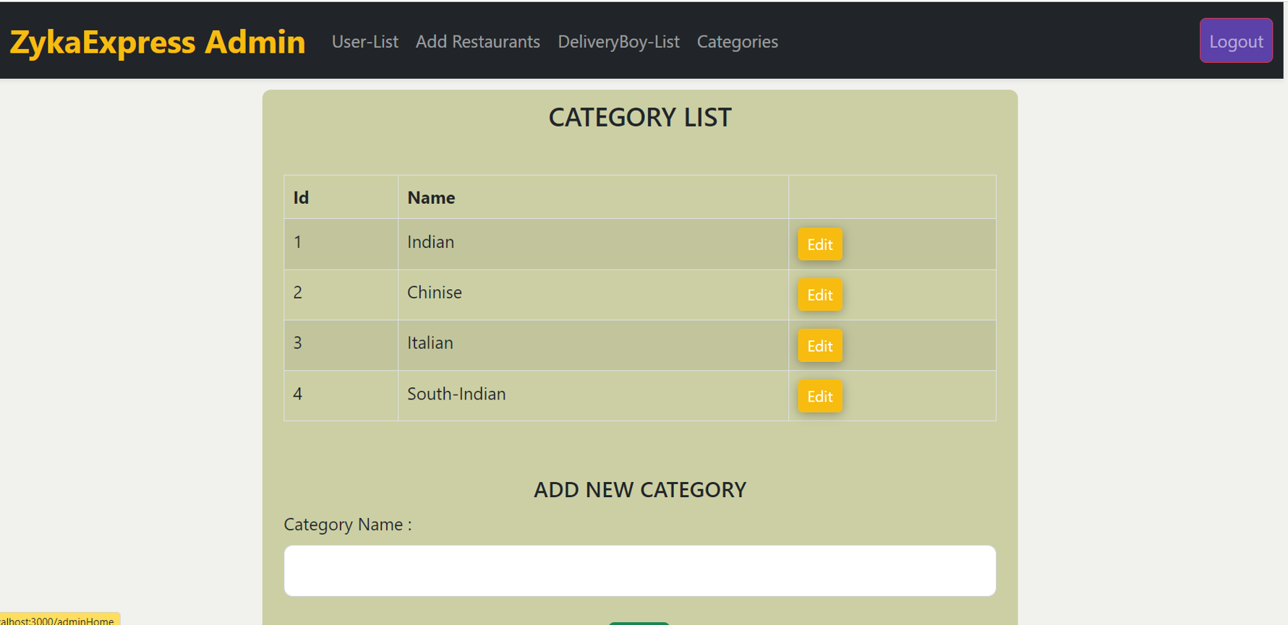

Contact Us

